Results from N12 Run #376-1

Date and Time Report Generated: 09/05/2023 12:18:51

Machine number ran on- 1

N2 version: 1.0

Main Code version: 1.0

Parameter Matrix Generator version: 1.1

Parameter Checker version: 1.1

CSV Generator version: 1.2

Method of Lines version: 1.1

Residual-Jacobian Calculator version: 1.1

Report Generator version: 1.8

___________

# Parameter Set 0

Step-size (h) : 0.01 Initial time (t1) : 0.0 Final time (t2) : 20.0 Mesh size (nx) : 100.0

Effective diffusivity (omega) : 1.0 Dimensionless attachment rate constant (mu): 0.2

Dimensionless binding site density (nu): 250.0 Minimum interstitial porosity (phi_min): [0.25]

Maximum porosity (phi_max): [0.8] Tolerance: 1e-08

Dimensionless equilibrium constant (kappa): 0.001 Binding Site Profile Shape Parameter (a): 14.0

Interstitial Porosity Profile Shape Parameter (b): 30.0 Total Porosity Profile Shape Parameter (c): 1.0

Partition Coeffecient (Kp): 1.0

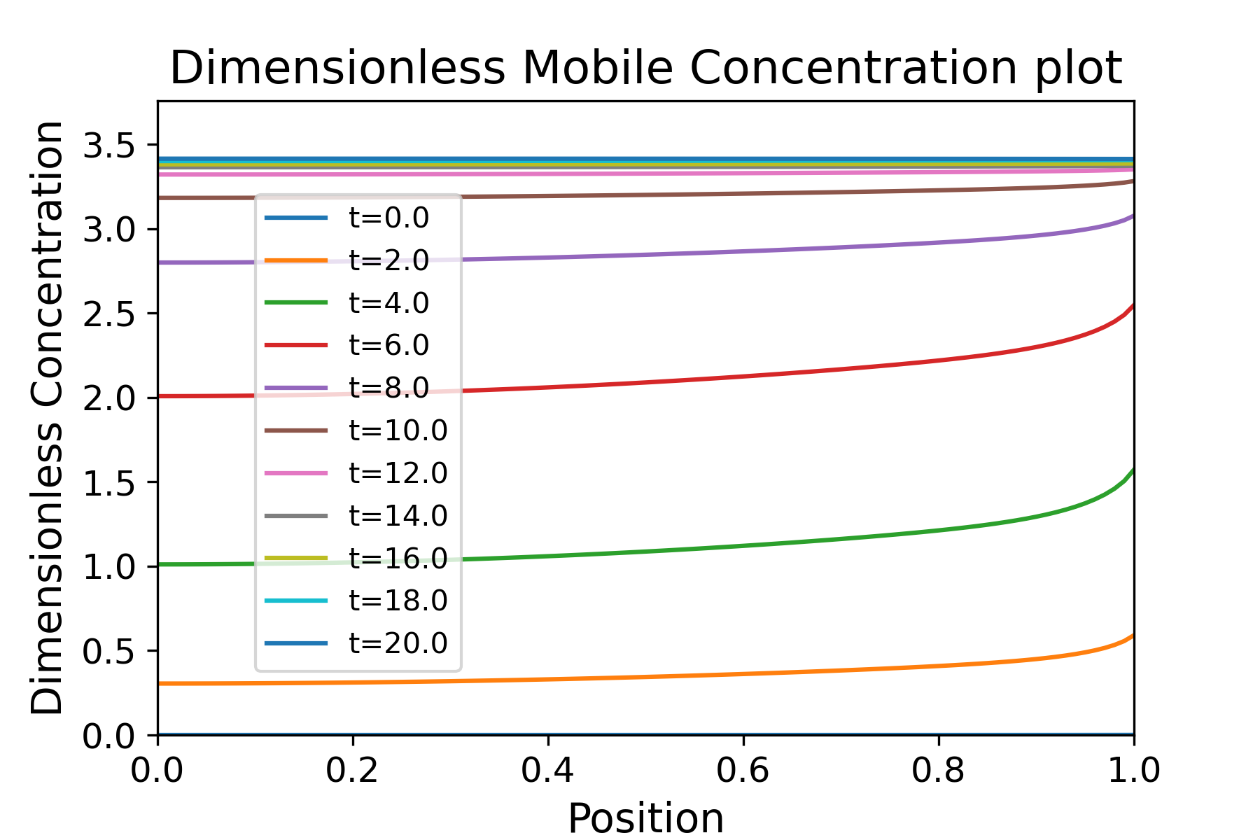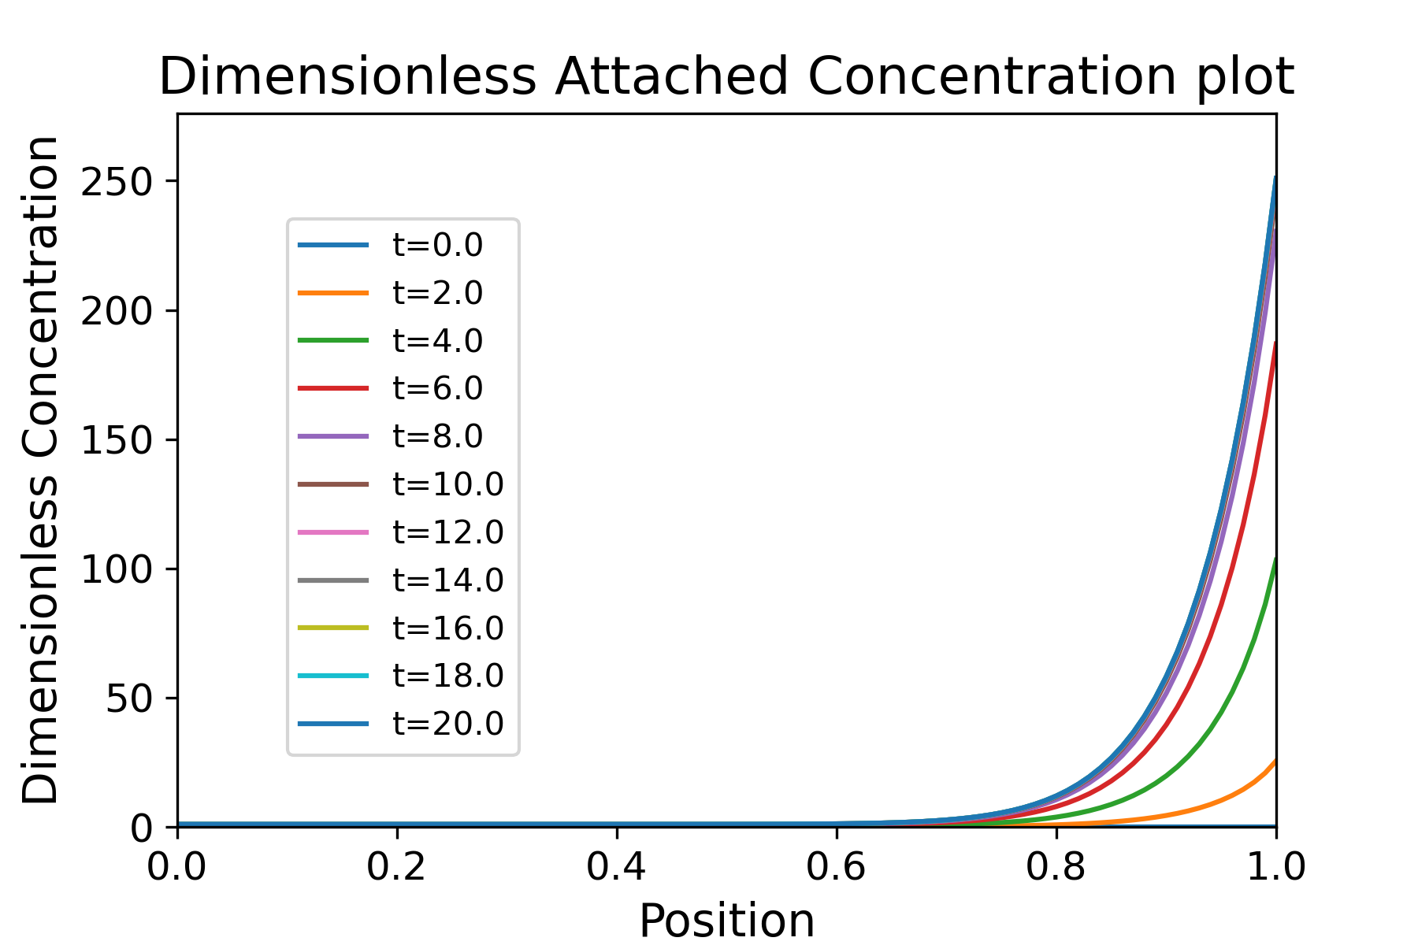

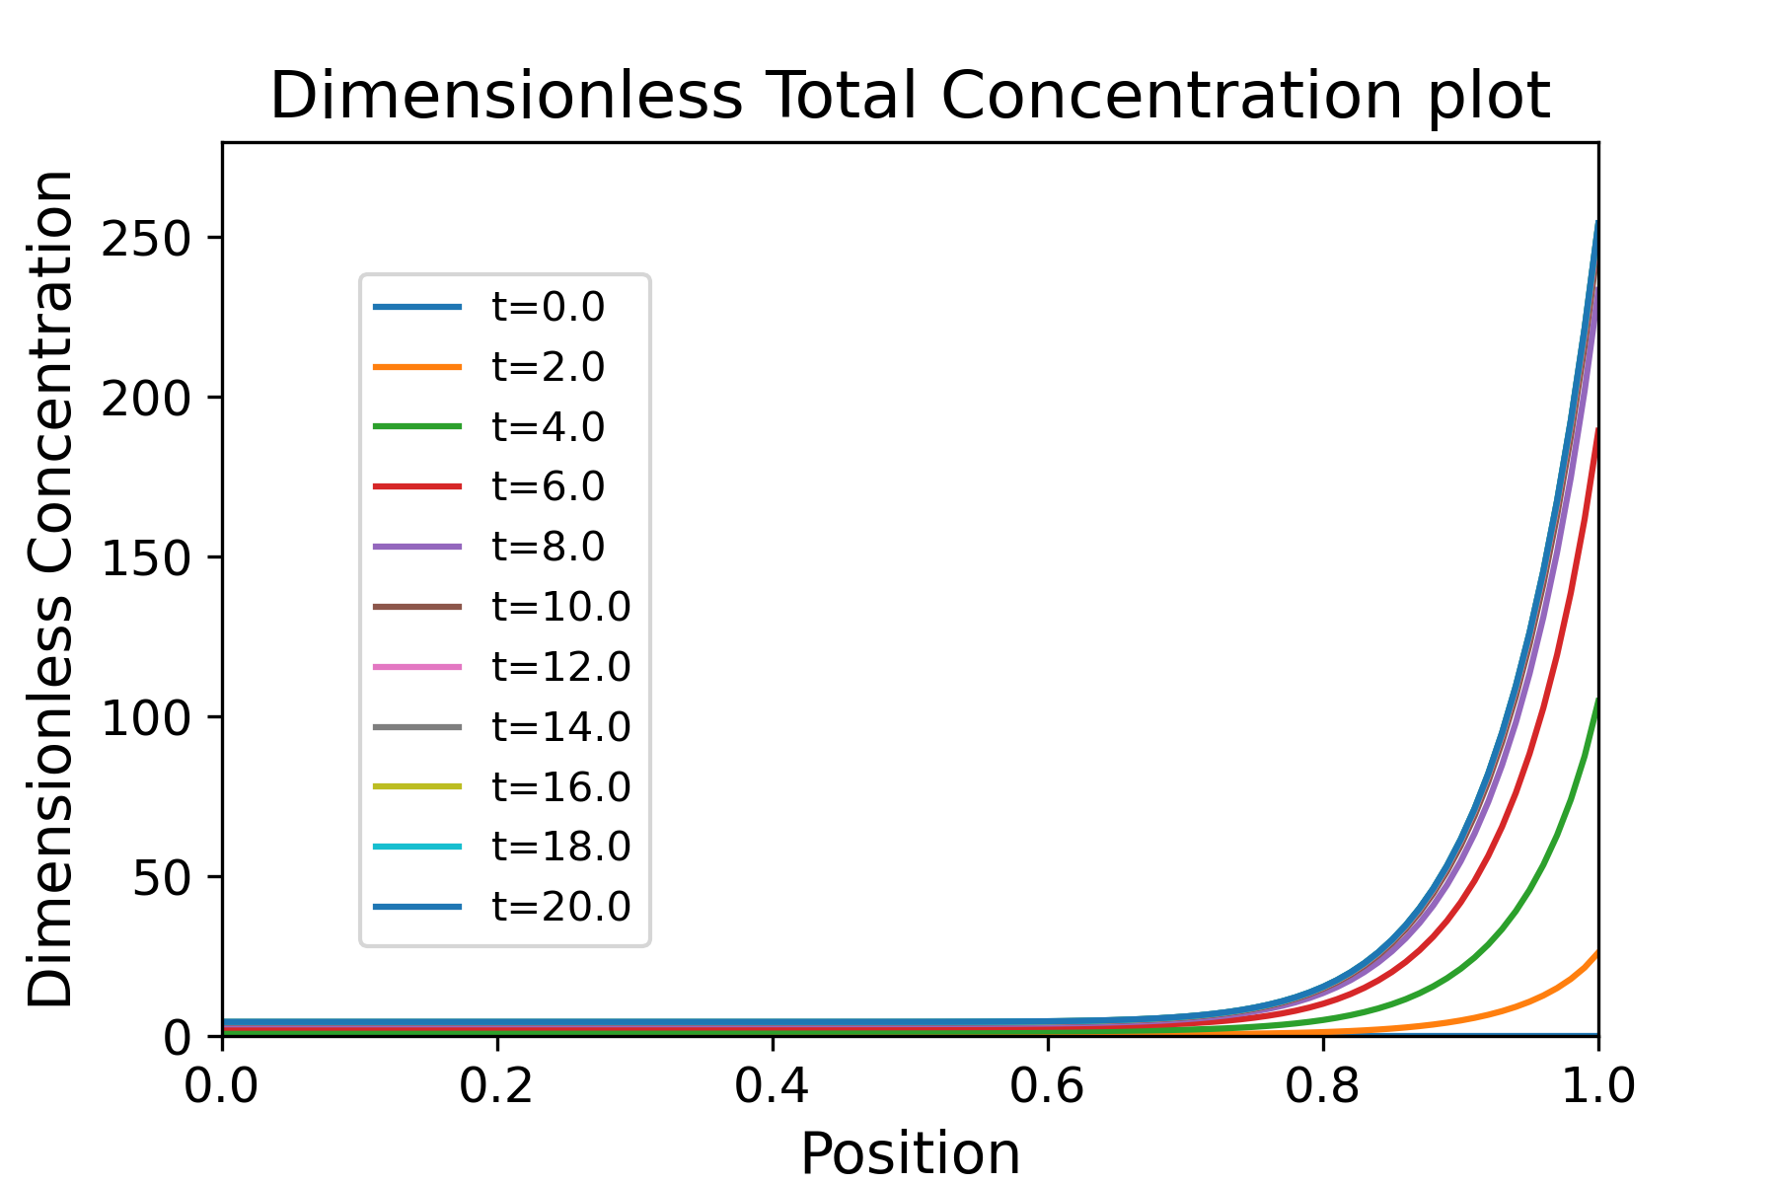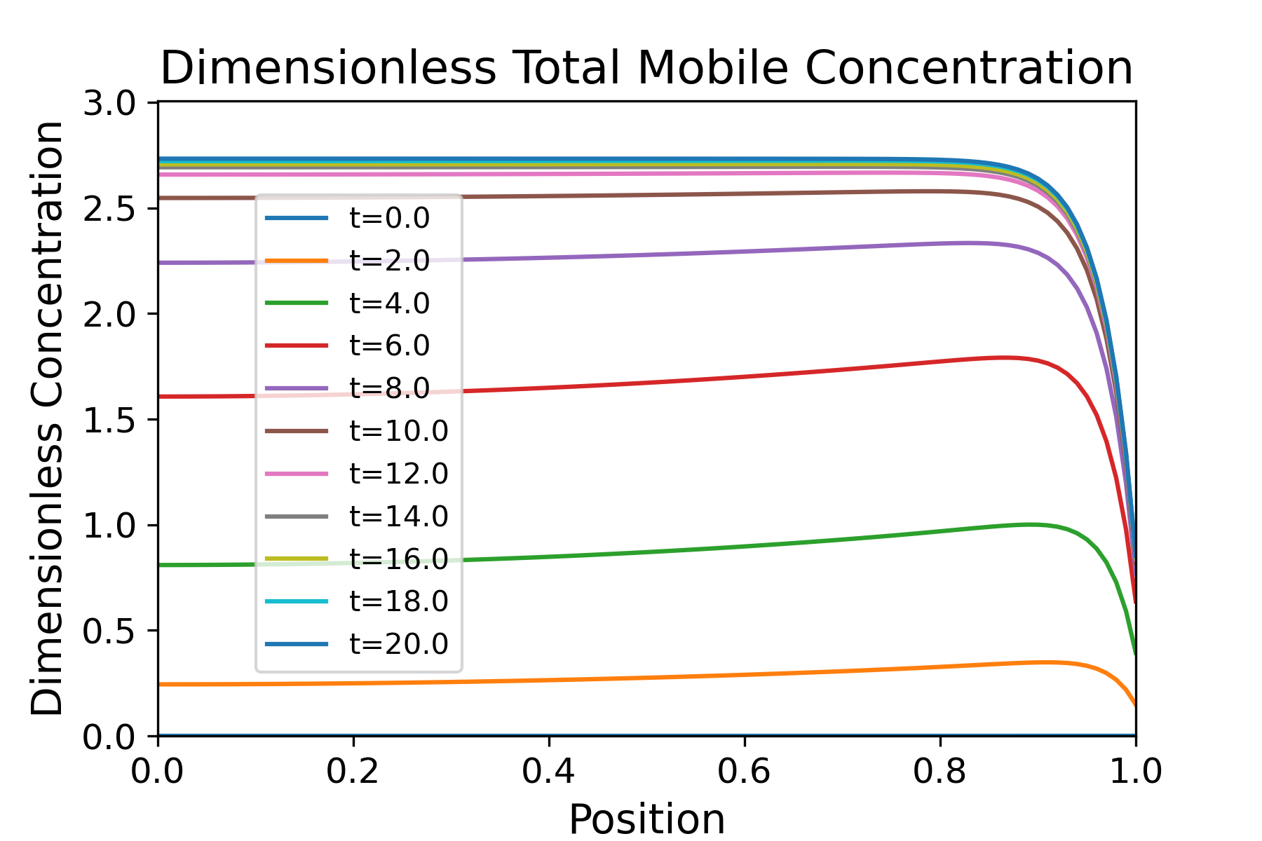

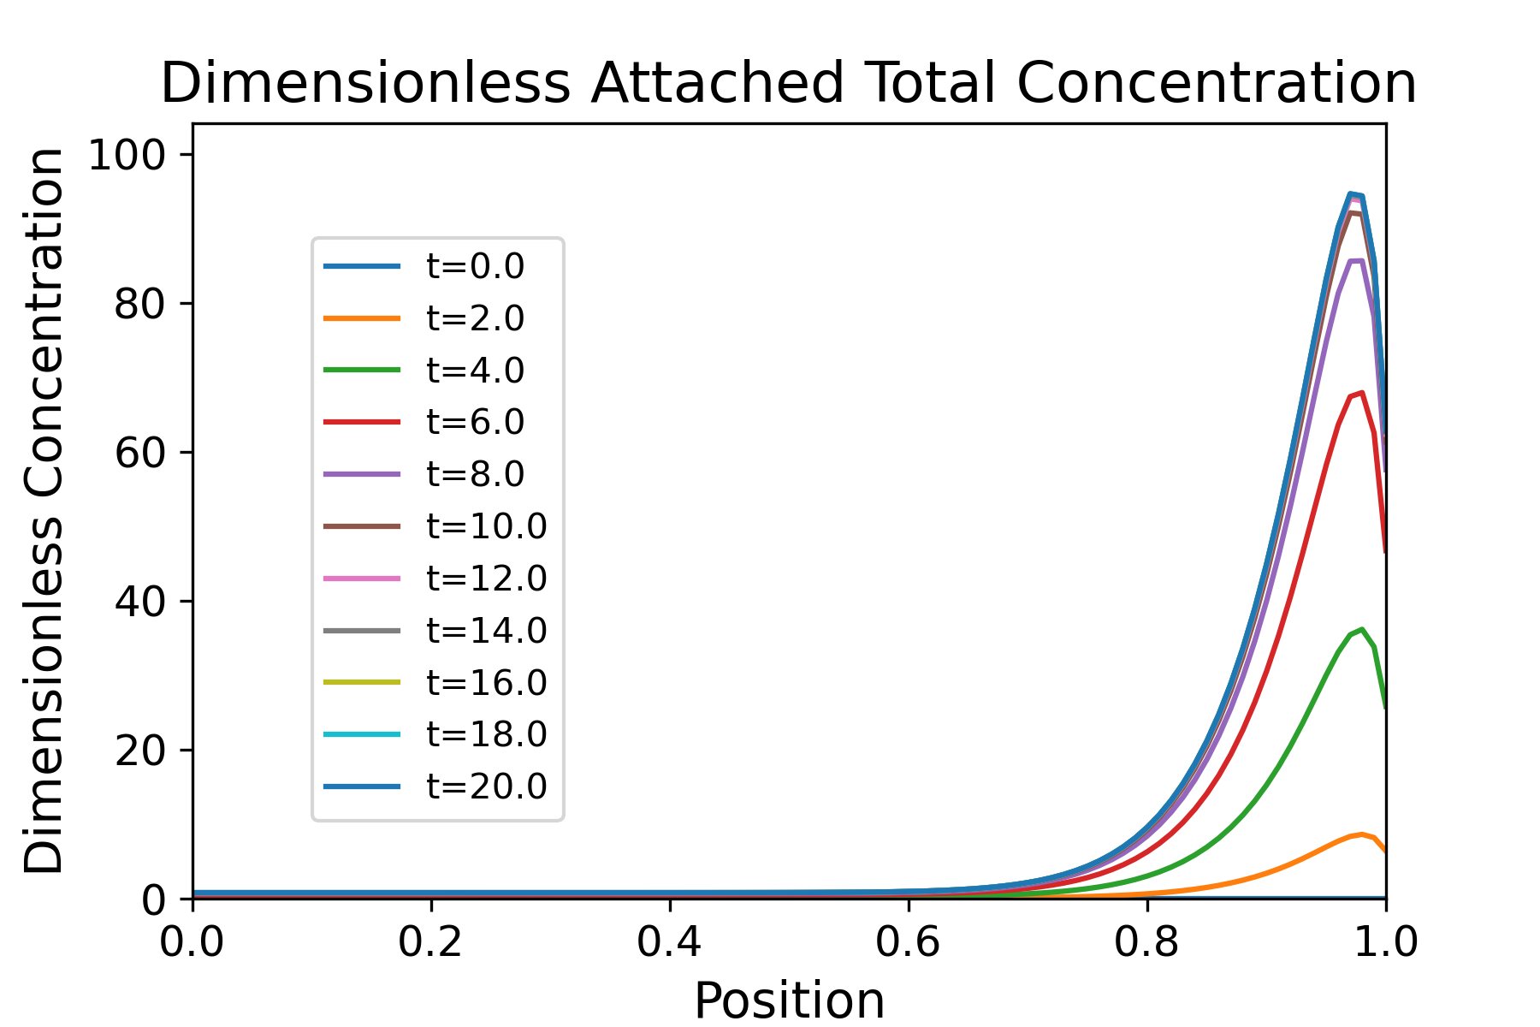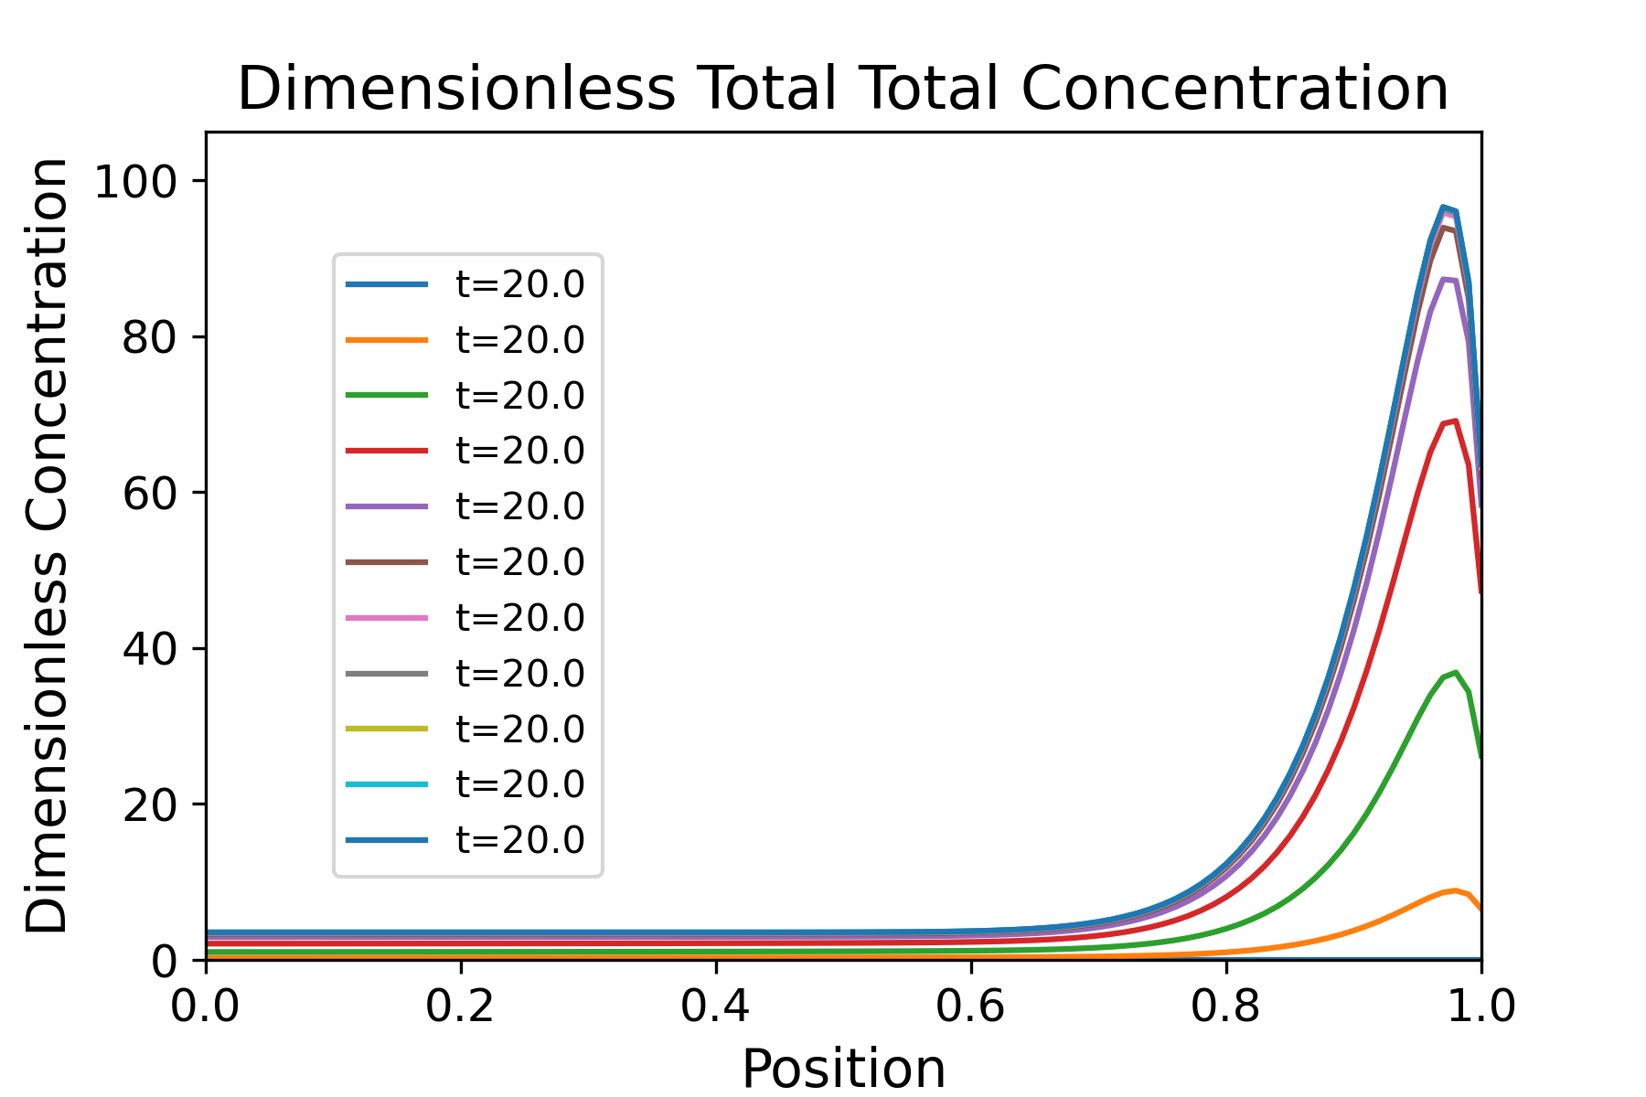

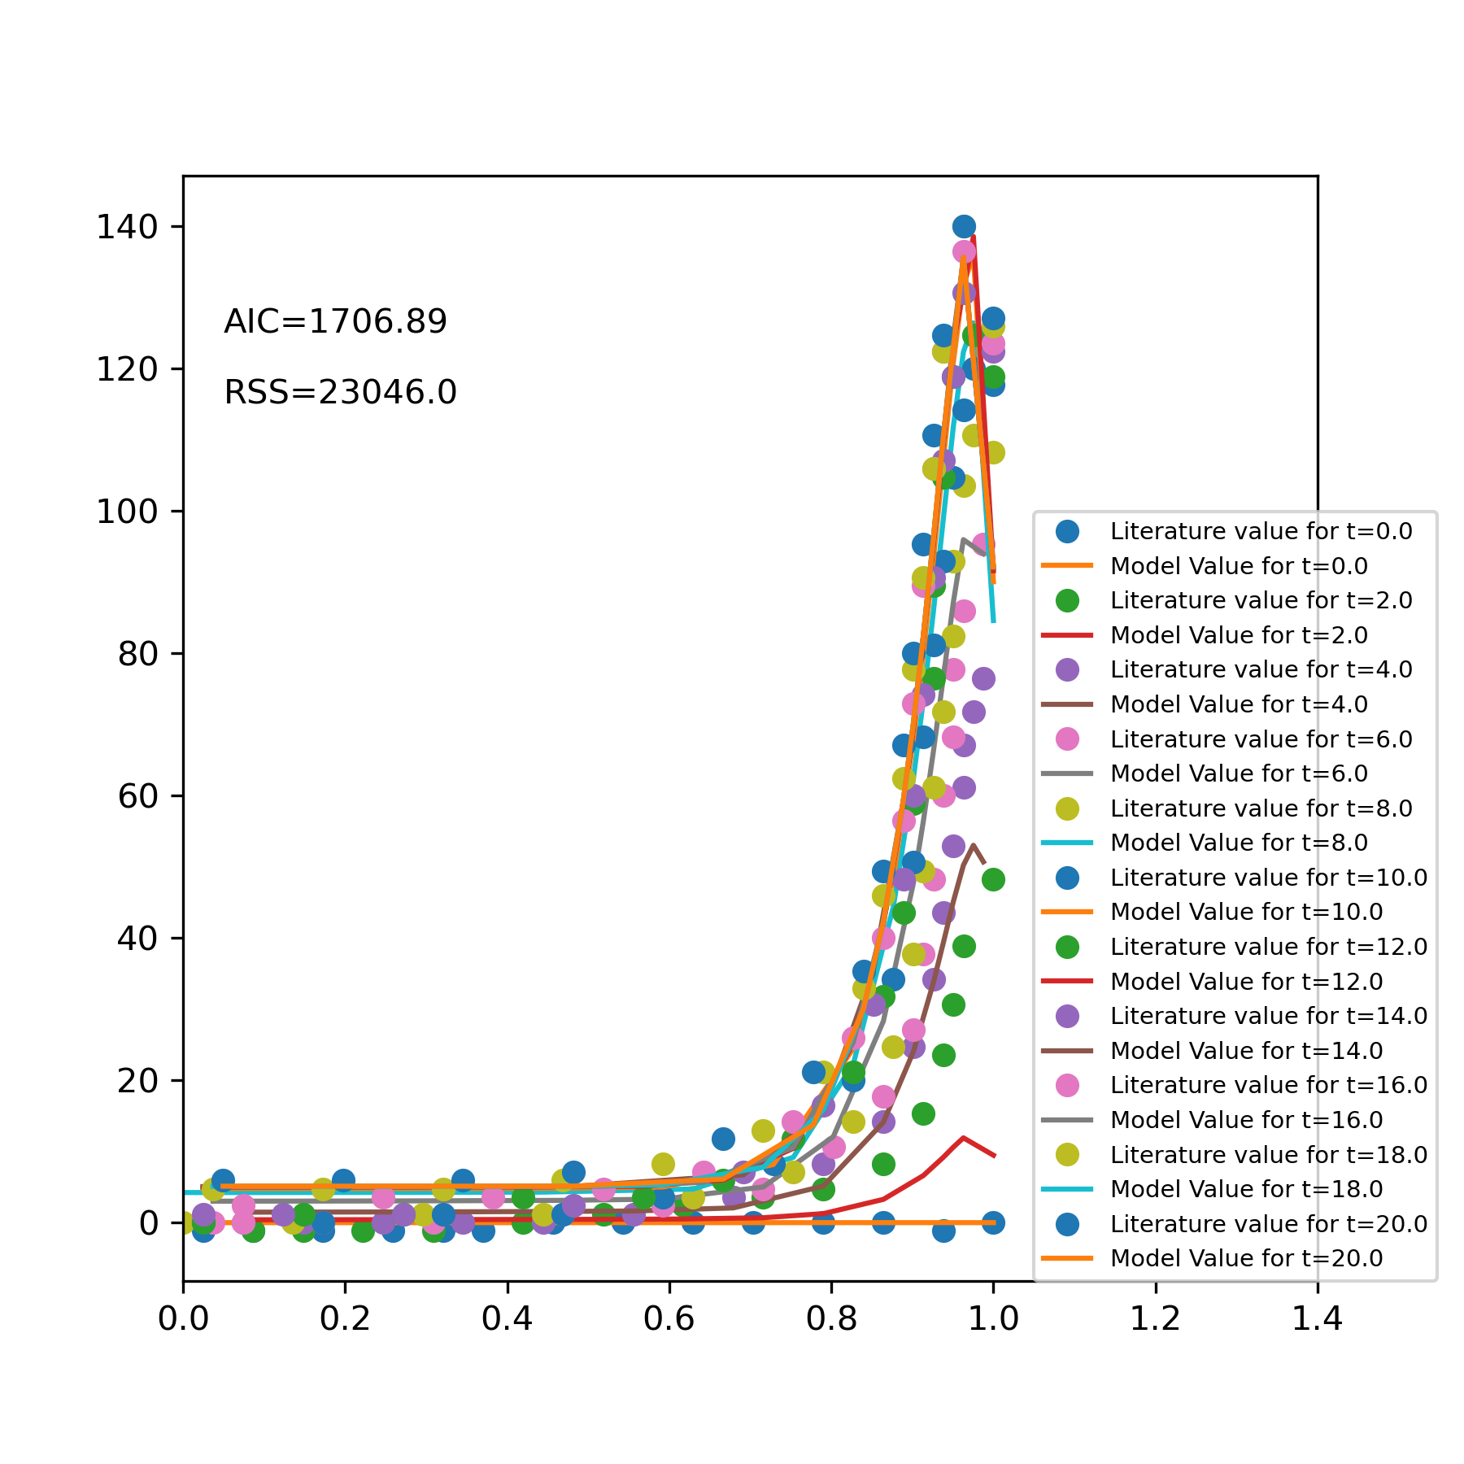

Time to Run (sec): 16.88271737098694